Database Management with ORM stack

Contents

1. Introduction 3
2. Workflow diagram to deploy the stack 3
3. Create stack for Database Management 4
4. Plan the Job 6
5. Apply the Job 7
6. Verify in the Console 8
7. Destroy the stack 9

Introduction

This resource provides the Managed Database Group resource in Oracle Cloud Infrastructure Database Management service.Managed Databases across compartments can be grouped together as part of a Database Group, which is an Oracle Cloud Infrastructure resource. A Database Group is useful to monitor and manage critical databases across compartments and it also enables to perform administrative operations on all the databases in a Database Group.

Workflow diagram to deploy the stack

Below diagram shows how the Terraform Artifact are applied in the OCI. While creating a ORM stack, using terraform deliverables Init, Plan and Apply is the flow to provision the resource in the OCI. We can have the deliverables in any of below.

- GitLab/GitHub Repo
- Bitbucket
- Can be in folder/.zip in the local disk
- Object Storage Bucket
- Can be in compartment
- Oracle provided Template


Create stack for Database Management

Go to OCI Console Developer Services Resource Manager Stacks select the compartment Create Stack

My Configuration Folder Browse Select the “DB_Management” folder that contains the terraform Upload

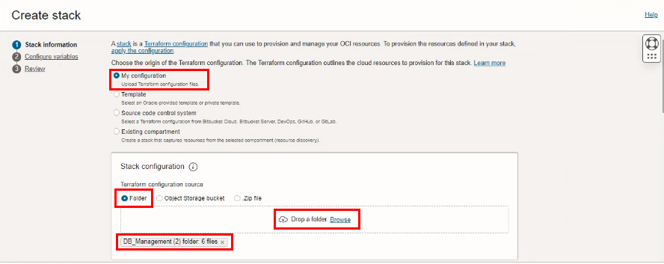
Select the parameters as per the below screen,
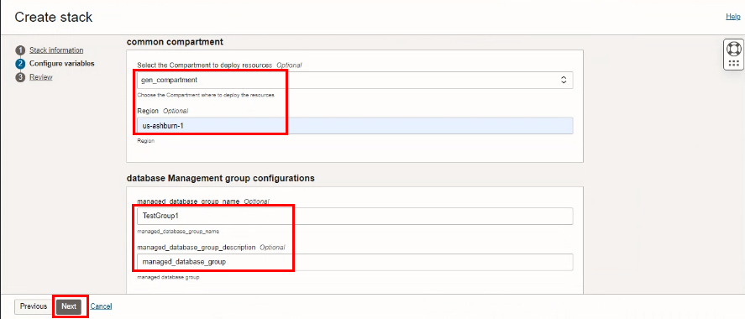

Click “NEXT”
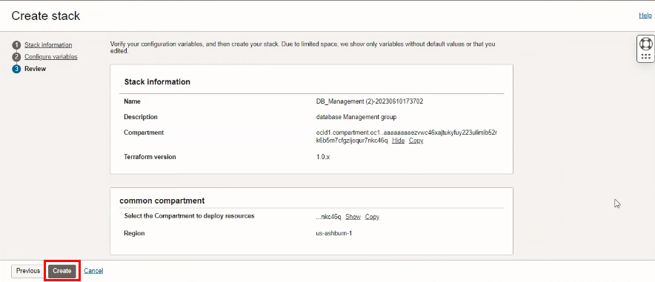
Click “CREATE”

Plan the Job

Click the “Plan”
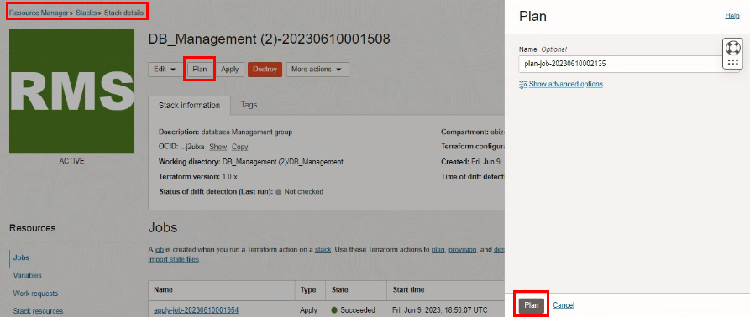

Verify the Plan is successful.
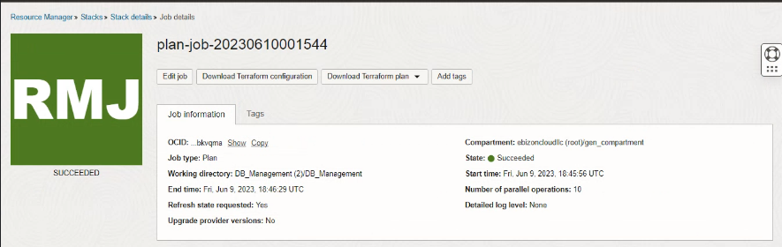

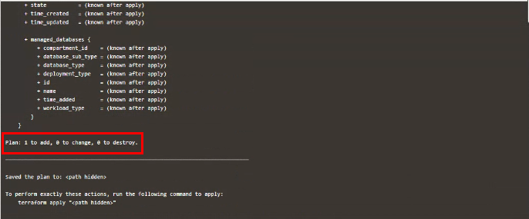

- Apply the Job

Once the “plan” is success, now click “Apply”
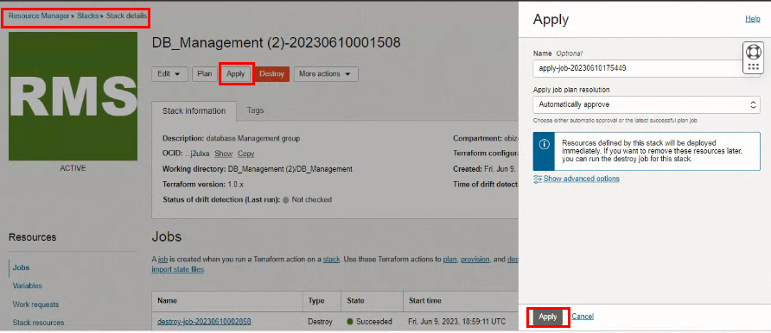

Verify the Apply is successful.
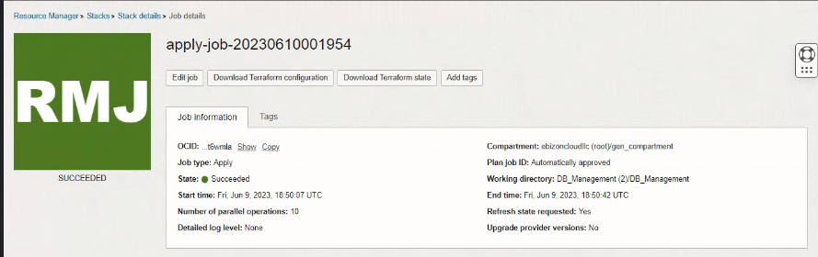

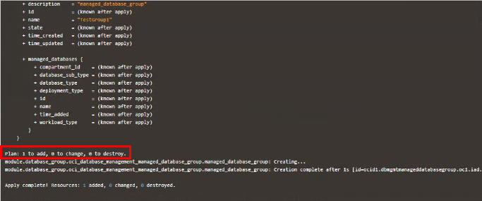

Verify in the Console

Go to OCI Console Observability & Management Database Managemnt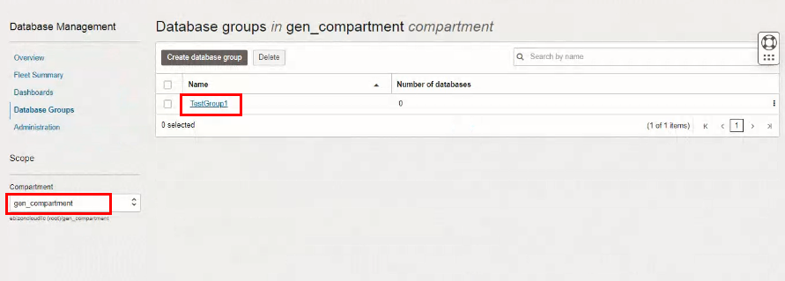

Go to OCI Console Observability & Management Database ManagemntDatabase Group
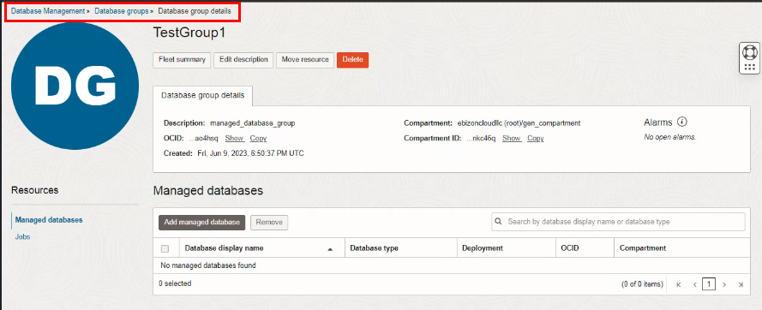

Destroy the stack

Create a destroy job in Resource Manager to release resources associated with a stack and clean up the tenancy. Once destroyed data cannot be recovered from resources.
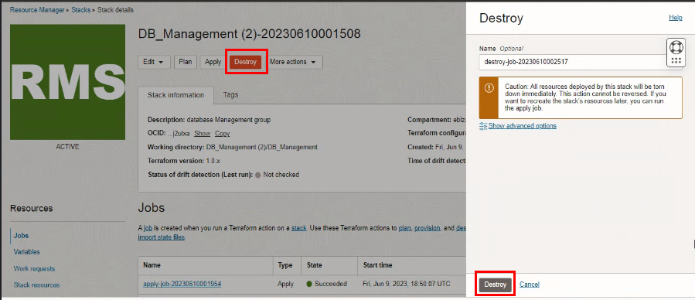

#END#

